GSM/GPRS/GPS TRACKER
MANUAL

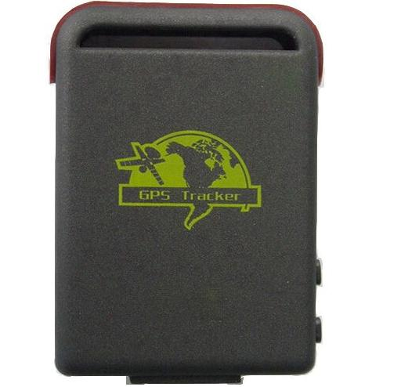

Preface

Thank you for purchasing the tracker. This manual shows how to operate the device smoothly and correctly. Make sure to read this manual carefully before using this product. Please note that specification and information are subject to changes without prior notice in this manual. Any change will be integrated in the latest release. The manufacturer assumes no responsibility for any errors or omissions in this document.

Content
1. Summary 3
2 Applications 3
3 Hardware Description 3
4 Specs. 4
5 Usage 4
5.1 SIM card installation 5
5.2 Battery and Charger 5
5.3 Startup 5
5.4 Initialization 6
5.5 Change the password 6
5.6 Authorization 7
5.7 Single Locating 7
5.8 Get absolute street address 8
5.9 Auto Track 8
5.10 Location based service (LBS) 9
5.11 Monitor (Voice Surveillance) 9
5.12 Storage 9
5.13 Data Load 10
5.14 Shock sensor alarm 11
5.15 Geo-fence 11
5.16 Movement alert 11
5.17 Overspeed alert: 12
5.18 SOS button 12
5.19 Low battery alert 12
5.20 State Checking 12
5.21 IMEI checking: 12
5.22 Terminal (local) Time Setting 13
5.23 GPRS setting 13
5.24 Modes switch between “SMS” and “GPRS” 14
5.25 Web platform and PC installation tracking software 14
6 .Cautions 14
7 Faults & The solutions 15

1. Summary
Working Based on existing GSM/GPRS network and GPS satellites, this product can locate and monitor any remote targets by SMS or internet.
Overview of the characteristicst:
1.GPS, GSM dual position.
2.GSM 850/900/1800/1900MHZ 4 frequency globally applicable.
3.When GPS positioning downturn, will use GSM positioning, global positioning, support most countries around the world.
4.Use local language to reply real address, supports languages: Chinese, English, Russian, Spanish, Portuguese, German, French and Arabic.
5.Support TF card, GPS location information automatically stored when the GSM signal is bad, so the route trajectory seamless point, breakpoint.
6.Auto set APN.
7.Built-in shock SENSOR.

2 Applications
- Vehicle rental / Fleet management etc
- Powerful magnet+water proof, adsorbing in the hidden place of car for tracking secretly.
- Protect child / the old / the disabled / pet etc
- Provide peace-of-mind for businessmen
- Personnel Management
- Criminals Tracking

3 Hardware Description
3.1 Front face 3.2 Rear face
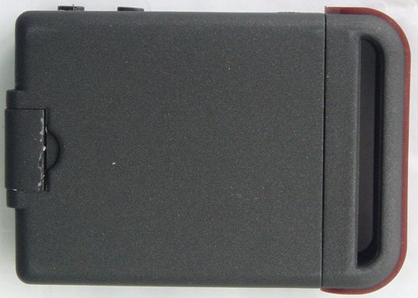

3.3 Side face
Indicator for signals.
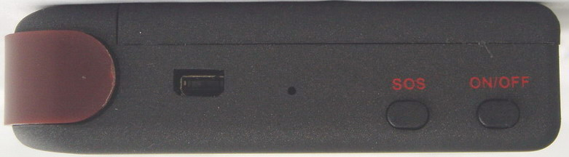
You can update software, charge battery from here.

SOS Button
ON /OFF Button

Built-in GSM/GPRS antennas is inside
Microphone
3.4 Bottom face

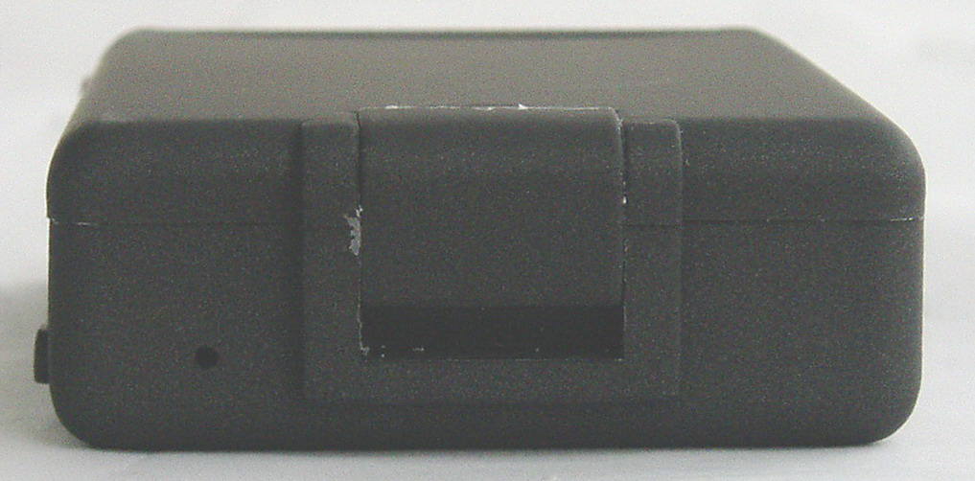

3.5 Interior
GSM Card Slot
Install the battery like this
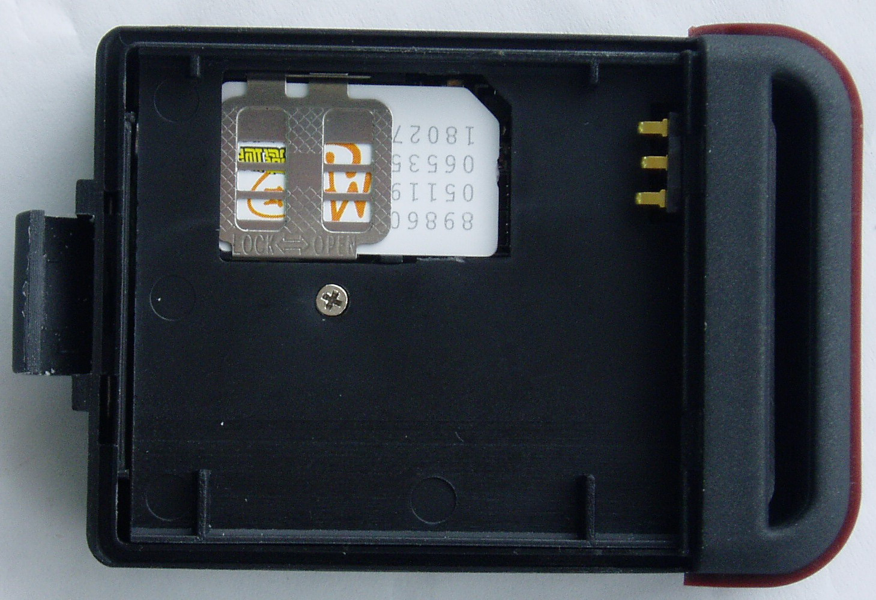

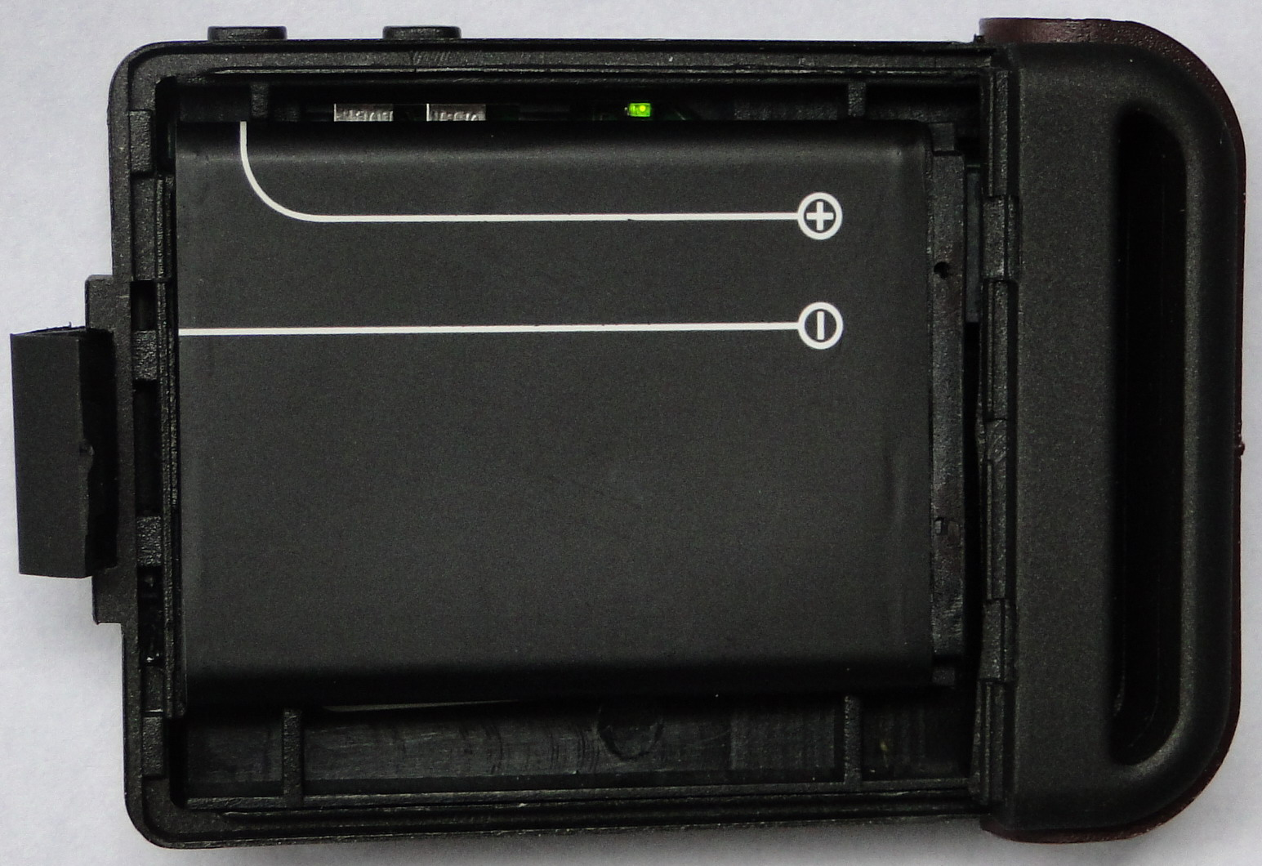

4 Specs.
Content | Specs.
Dim. | 64mm x 46mm x 17mm(1.8”*2.5”*0.65”)
Weight | 50g
Network | GSM/GPRS
Band | 850/900/1800/1900Mhz
GPS chip | SIRF3 chip
GPS sensitivity | -159dBm
GPS accuracy | 5m
Time To First Fix | Cold status 45s  Warm status 35s  Hot status 1s
Car charger | 12—24V input  5V output
Wall charger | 110－220V input  5V output
Battery | Chargeable changeable 3.7V 800mAh Li-ion battery
Standby | 80hours
Storage Temp. | -40°C to +85°C
Operation Temp. | -20°C to +55°C
Humidity | 5%--95% non-condensing

5 Usage

5.1 SIM card installation
Make sure that there is no call transfer and call display is on, and PIN code off. The SMS message must in Text format, can’t be identified for PDU format.
Steps:
5.1.1 Open the rear cover, and pick out the battery.
5.1.2 Push the foil up according the arrow on the foil and load the miscro SD card and push back.
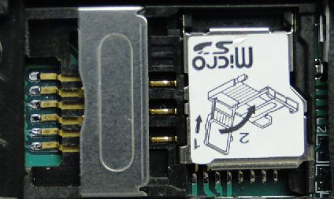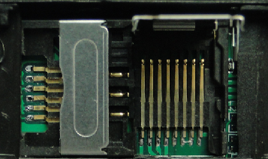
5.1.3 Put the SIM card into the holder as picture shows.
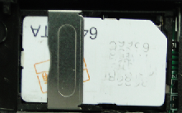

5.2 Battery and Charger
Do charge the battery to capacity in 8 -12 hours for first time. Please use the battery and charger provided by the manufacturer. This unit adopts built-in Li-ion battery, and full battery can standby 120 hours. After first use, the battery usually should be charged fully in 3-5 hours.
Cautions:
a: For it’s Li-ion battery, which contains harmful chemicals and may burst, please don’t bump, puncture it violently and keep it off fire.
b: Please charge the battery in time to keep it working normally.

5.3 Startup
- Put the SIM card and battery in place.
- Turn on the unit outdoors by pressing the “on/off” button until the indicator is on.
- For first use, please initialize the unit and restore it to default setting. (Please refer to 5.4 for instruction.)
- In 10 or 40 seconds, the unit will begin to work and acquire the GSM signals as well as the GPS signals. The indicator will keep flashing every 3 seconds when the unit has received the signals.
- When this unit receives GPS signals normally, you can use it and do any setting as the instructions of this manual.

5.4 Initialization
Send “begin+password” in SMS to the unit, it will reply “begin ok” and initialize all the settings. (Default password: 123456)
For example, send SMS“ begin123456” to the tracker via a cell phone, If succeeded,
if will reply“begin ok”.

5.5 Change the password
5.5.1 Set Password: Send sms: “password+old password+space+new password” to the unit to change the password.
For Example, pls send sms: “ password123456 888888” to terminal device, it will reply sms: “password OK”. New password 888888 changed in success.

5.5.2 Be sure keep the new password in mind, you have to upload the software to restore the original setting in case of losing the new password.
5.5.3 Make sure the new password is in 6 digits Arabic numbers, or the tracker can not recognize the password.
5.5.4 Make sure that all the symbol“+”in sms commends is just for quick understanding, which don’t need to enter “+” in sms, and “space” means press the spacebar button of the cell phone.

5.6 Authorization
There are only 5 cell phone numbers able to be authorized, be sure to set the authorization phone number before use.
5.6.1 Call the tracker for 10 times continuously and get position correctly, then it will make the cell phone number as the authorized number automatically.
5.6.2 Send SMS：“ admin+password+space+cell phone number” to set up a authorized number. The other authorized numbers should be set by the first authorized number. If the number is successfully authorized, the unit will reply “admin ok!” in SMS.
5.6.3 Send SMS：“ noadmin+password+space+authorized number” to delete the authorized number.
5.6.4 For roaming purpose, you have to add your country code ahead of the cell phone number, for example, please send：“ admin123456 +8613322221111” to tracker to set 13322221111 as an authorized number.

5.7 Single Locating
5.7.1 If there is no authorized number, when any number dials up the unit, it will report a Geo-info; If there is already an authorized number, then it will not respond when an unauthorized number calls it up.
5.7.2 When an authorized number dials up the unit, it will hang up and report a real-time Geo-info as below:
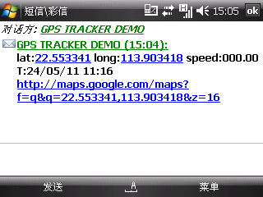
When GPS signals is weak,if in 90s,GPS can not location,will use LBS location,the replied SMS as below:
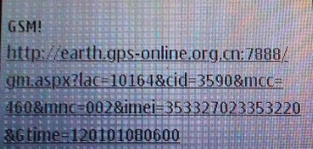
Open the link,you can get the position and the map.
* This feature can be used normally in most areas according to the signal of GSM network. It may not be available in some areas

5.8 Get absolute street address
5.8.1 You must register our server if want to use this function,If you want the SMS reply with local language,please use local telecom mobile operator sim card.
5.8.2 send:” address+password” to device, it will reply SMS including absolute street address. For example:Block 13,28 Cheung Sha Wan Road,Kowloon,Hongkong.

5.9 Auto Track
5.9.1 Send SMS command “t030s005n+password” to the tracker device, it will report the Geo-info at 30s intervals for 5 times. (s:second, m:minute, h:hour). This command setting must be in 3 digits.
5.9.2 Unlimited times auto track: Send SMS “t030s***n+password” to the tracker device, it will reply the Geo-info continuously at 30 seconds intervals.
5.9.3 Cancellation: Send SMS “notn+password” to the tracker device.
Note: the interval must not less than 20s.

5.10 Location based service (LBS)
When the tracker device doesn’t received valid GPS signals, tracker will locate by LBS.
Note: This feature can be used normally in most areas according to the signal of GSM network. It may not be available in some areas.

5.11 Monitor (Voice Surveillance)
5.11.1 The command to switch between Track and Monitor are “tracker” and “ monitor”.
5.11.2 The default mode is “track” (Track mode).
5.11.3 Send SMS “monitor+password” to the unit, and it will reply “monitor ok!” and switch to “monitor” mode.
5.11.4 Send SMS “tracker+password” to the unit, it will reply “tracker ok!” and restore to “track” mode.

5.12 Storage
5.12.1 Auto Storage：When the tracker devices lost GSM signals or fall offline from GPRS, tracker will store the tracking position and alerts automatically in the flash upon the pre-set condition, when GSM signals get back, all the event alerts will be auto-sent to the authorized numbers or monitoring platform (server), but the stored tracking data should be loaded to the monitoring platform via SMS command.
5.12.2 Storage upon times: Send SMS: “save030s005n+password” to the tracker unit, it will reply “save ok”, and will store the lat, long locations every 30 seconds for 5 times. (S: second, m: minute; h: hour).
5.12.3 Multi-Storage：Send sms:”save030s***n+ password” to tracker device, it will reply “save ok”.
5.12.4: Storage Clearance: send SMS: “clear+ password” to tracker device, it will reply “clear ok”.
5.12.5：Storage Volume: external TF card support 32GB at most.

5.13 Data Load
5.13.1 Current date Load: Send SMS: “load+ password” to tracker device, it will reply: “load ok” if the device is working well under GPRS mode; if not, it will reply “load fail! Please check gprs” that means device does not work under GPRS mode.
5.13.2 Specified date Load： Send SMS: “load+ password+ space+ year month date” to tracker device, it will reply: “load ok” and load the tracking data to the monitoring platform upon the valid time you choose. For Example: send SMS: “load123456 20110425” to the tracker device, means to load the tracking data of 25th April 2011 to monitoring platform.

5.14 Shock sensor alarm
It is disabled as default, send “shock+password to tracker, tracker will reply “shock ok!”. “Sensor alarm+lat/long” will send to authorized phone number when tracker is being shocked, and one alarm for each shock event trigger.

Cancel: Send “noshock+password” to cancel the shock sensor alarm.

5.15 Geo-fence
Set up a geo-fence for the unit to restrict its movements within a district. The unit will send the message to the authorized numbers when it breaches the district.
5.15.1 Set up: When the unit stays immobile in a place for 3-10 minutes, the user can Send SMS: “stockade+password+space+latitude,longitude; latitude,longitude” to unit to set the restricted district. In case of breach, it will send SMS “stockade!+geo-info” to the authorized numbers every 3 minutes.
Remark: The first latitude&longitude is coordinate of the top left corner of the Geo-fence, while the second latitude&longitude is the coordinate of the bottom right corner.
5.15.2 Cancel: Send SMS:” nostockade+password” to deactivate this function.

5.16 Movement alert
5.16.1 Set up: When the unit stays immobile in a place for 3-10 minutes, the user can send SMS: “move+password” to the unit, then the unit will reply “move ok!”. In case of such a movement（the unit default distance is 200M）, it will send SMS “Move+ Geo-info” to the authorized numbers every 3 minutes.
5.16.2 Cancel: Send SMS:” nomove+password” to deactivate the movement alert.

5.17 Overspeed alert:
5.17.1 Set up: Send SMS:” speed+password+space+080” to the unit (suppose the speed is 80km/h), and it will reply “speed ok!”. When the target moves exceeding 80 km/h, the unit will send SMS :”speed+080!+Geo-info” to the authorized numbers every 3 minutes.
5.17.2 Cancel: Send SMS “nospeed+password” to deactivate the overspeed alarm.
Remark: The recommended speed should be not less than 50km/h. For below that rate, it will be effected the accuracy by gps signals drift etc.

5.18 SOS button
Press the SOS for 3 seconds, it will send “help me!+ Geo-info” to all the authorized numbers every 3 minutes. It will stop sending such a SMS when any authorized number reply SMS “help me!” to the tracker.

5.19 Low battery alert
When GPS device battery is going to be about 3.7V, it will send SMS:”low battery+Ge-info”
at 3 minutes interval.

5.20 State Checking
Send SMS:”check+password” to the tracker device, it will reply the recent status via SMS as: GSM: 100% GPS: OK/NO GPRS: ON/OFF battery: 100%.

5.21 IMEI checking:
Send SMS command "imei+password" to the unit. E.g.: Send SMS command "imei123456" to the unit, an IMEI number in 15 digits will be replied to your cell phone.

5.22 Terminal (local) Time Setting
5.22.1 Send SMS “time+space+zone+password+space+local time zone”.
For example, Send SMS “time zone123456 8” (time zone of China).
If the local time zone is negative as “-8”, then it should set as SMS:
“time zone123456 -8”.

5.23 GPRS setting
The device can auto set APN,the function support most countries,the default IP is our company IP.User can use SMS or our setting software set the parameter.
5.23.1 Setting up APN
5.23.1.1 APN standards for Access Point Name and differs from country to country. For more information about the local APN, inquire with your local GPRS network operator.
5.23.1.2 Text the tracker a SMS “APN+password + Space + your local APN+APN user name+apn password”.
If need no APN user,apn password,the SMS format is: “APN+password + Space + your local APN.for example:apn123456 cmnet claro claro,mean:local APN:cmnet,APN user:claro,APN password:claro.
If need not APN user,APN password:the format is:apn123456 cmnet.
5.23.2 Send SMS command “adminip123456 202.194.155.78 9999” to the tracker device, If succeeded, “adminip OK” is returned by the device in SMS.( 123456 is default password，202.194.155.78 is IP，9999 is port).

5.24 Modes switch between “SMS” and “GPRS”
5.24.1 The default mode is “SMS”
5.24.2 Send SMS “GPRS+password” to the unit, and it will reply “GPRS ok!” and switch to “GPRS” mode.
5.24.3 Send SMS “SMS+password” to the unit, it will reply “SMS ok!” and restore to “SMS” mode.

5.25 Web platform
5.25.1 Web based platform: new.gps-online.org.IP: 211.154.136.232,port:11188.

6 .Cautions
Please comply with the instructions to extend the unit life:
6.1 Keep the unit dry. Any liquid, i.e. rain, moisture, may destroy or damage the inside circuitry.
6.2 Don’t use & store the unit in dusty places.
6.3 Don’t put the unit in overheated or overcooled places.
6.4 Handle carefully. Don’t vibrate or shake it violently.
6.5 Clear the unit with a piece of dry cloth. Don’t clean in chemicals, detergent.
6.6 Don’t paint the unit, this may cause some foreign materials left in between the parts.
6.7 Don’t disassemble or refit the unit.
6.8 Please use the battery and charger provided by manufacturer. Using other batteries and chargers will cause unwanted situation.

7 Faults & The solutions
Faults | Solution
Startup Fail | Check the battery and see if it is fully charged or  correctly installed.
Hang up Fail | In existence of an authorized number, an unauthorized  number dials up the unit. Please initialize the unit and re-set up  the authorized numbers.
No GSM Signal | Please make sure SIM Card is GSM Net and installed correctly; also call display should be on; but no call transfer and PIN code off.

